**TRAINING REPORT**

on

**Online Education Website**

Submitted in partial fulfillment of the

Requirements for the award of

**Degree of Bachelor of Engineerig in Computer Science & Engineering**



Submitted By

Name: Ravi Anand

University ID: 18BCS6553

Training Group: CSG43

(Times New Roman, 14 pt. Bold)

**SUBMITTED TO:**

**Department of Computer Science & Engineering**

Chandigarh University

Gharuan, Mohali

1. Introduction:

This website is an online service to provide educational resources to the students and checking their capability in different subjects by providing them practice paper and according to that giving them points. These points can be used to unlock different paid services in our websites. Given the improvements in delivery methods, online learning environments provide a greater degree of flexibility than traditional classroom settings.

The diversity comes from interacting with students outside of one's geographical location, possibly offering a variety of perspectives on course content. Courses offered completely online are primarily delivered in an asynchronous learning or synchronous learning format. Participation and interaction between participants and instructors involves significant and continuous preparation.

The mentoring of novice online educators from those with experience can assist with the transition from classroom to the virtual environment.

The next disruptor will likely mark a tipping point: an entirely free online curriculum leading to a degree from an accredited institution. With this new business model, students might still have to pay to certify their credentials, but not for the process leading to their acquisition. If free access to a degree-granting curriculum were to occur, the business model of higher education would dramatically and irreversibly change.

Course developers could charge licensing fees for educational institutions that use its materials. Introductory or "gateway" courses and some remedial courses may earn the most fees. Free introductory courses may attract new students to follow-on fee-charging classes. Blended courses supplement MOOC material with face-to-face instruction. Providers can charge employers for recruiting its students. Students may be able to pay to take a proctored exam to earn transfer credit at a degree-granting university, or for certificates of completion.

Internet technology has enabled many forms of distance learning through [open educational resources](https://en.wikipedia.org/wiki/Open_educational_resources) and facilities such as [e-learning](https://en.wikipedia.org/wiki/Educational_technology) and [MOOC](https://en.wikipedia.org/wiki/Massive_open_online_course)s. Although the expansion of the Internet blurs the boundaries, distance education technologies are divided into two modes of delivery: [synchronous learning](https://en.wikipedia.org/wiki/Synchronous_learning) and [asynchronous learning](https://en.wikipedia.org/wiki/Asynchronous_learning).

In synchronous learning, all participants are "present" at the same time. In this regard, it resembles traditional classroom teaching methods despite the participants being located remotely. It requires a timetable to be organized. [Web conferencing](https://en.wikipedia.org/wiki/Web_conferencing), [videoconferencing](https://en.wikipedia.org/wiki/Videoconferencing), [educational television](https://en.wikipedia.org/wiki/Educational_television), [instructional television](https://en.wikipedia.org/wiki/Instructional_television) are examples of synchronous technology, as are [direct-broadcast satellite](https://en.wikipedia.org/wiki/Direct-broadcast_satellite) (DBS), [internet radio](https://en.wikipedia.org/wiki/Internet_radio), [live streaming](https://en.wikipedia.org/wiki/Live_streaming), [telephone](https://en.wikipedia.org/wiki/Telephone), and [web-based VoIP](https://en.wikipedia.org/wiki/Web-based_VoIP). Web conferencing software helps to facilitate meetings in distance learning courses and usually contain additional interaction tools such as text chat, polls, hand raising, emoticons etc. These tools also support asynchronous participation by students being able to listen to recordings of synchronous sessions. Immersive environments (notably Second Life) have also been used to enhance participant presence in distance education courses. Another form of synchronous learning that has been entering the classroom over the last couple of years is the use of robot proxies including those that allow sick students to attend classes

2. Tools and Technique:

Markup languages are ubiquitous in everyday computing. Although you may not realize it, word processing documents are filled with markup directives indicating the structure and often presentation of the document. In the case of traditional word processing documents, these structural and presentational markup codes are more often than not behind the scenes. However, in the case of Web documents, markup in the form of traditional Hypertext Markup Language (HTML) and its Extensible Markup Language (XML)-focused variant, XHTML, is a little more obvious. These not-so-behind-the-scenes markup languages are used to inform Web browsers about page structure and, some might argue, presentation as well.

In the case of HTML, markup instructions found within a Web page relay the structure of the document to the browser software. For example, if you want to emphasize a portion of text, you enclose it within the tags <em> and </em>.

There are markup elements, called empty elements, which do not enclose any content, thus need no close tags at all, or in the case of XHTML use a self-close identification scheme. For example, to insert a line break, use a single <br> tag, which represents the empty br element, because it doesn’t enclose any content and thus has no corresponding close tag:

<br>

However, in XML markup variants, particularly XHTML, an unclosed tag is not allowed, so you need to close the tag

<br></br>

or, more commonly, use a self-identification of closure like so:

<br />

The start tag of an element might contain attributes that modify the meaning of the tag. For example, in HTML, the simple inclusion of the noshade attribute in an <hr> tag, as shown here:

<hr noshade>

indicates that there should be no shading applied to this horizontal rule. Under XHTML, such style attributes are not allowed, because all attributes must have a value, so instead you have to use syntax like this:

<hr noshade="noshade" />

As the preceding example shows, attributes may require values, which are specified with an equal sign; these values should be enclosed within double or single quotes. For example, using standard HTML syntax,

<img src="dog.gif" alt="Angus-Black Scottish Terrier" height="100" width="100">

specifies four attributes for this <img> tag that are used to provide more information about the use of the included image. Under traditional HTML, in the case of simple alphanumeric attribute values, the use of quotes is optional, as shown here:

<p class=fancy>

Regardless of the flexibility provided under standard HTML, you should always aim to use quotes on all attributes. You will find that doing so makes markup more consistent, makes upgrading to stricter markup versions far easier, and tends to help reduce errors caused by inconsistency.

• The <!DOCTYPE> statement, which indicates the particular version of HTML or XHTML being used in the document. The first example uses the strict 4.01 specification, the second uses a reduced form for HTML5 the meaning of which will be explained a bit later on, and the final example uses the XHTML 1.0 strict specification.

• The <html>, <head>, and <body> tag pairs are used to specify the general structure of the document. The required inclusion of the xmlns attribute in the <html> tag is a small difference required by XHTML.

• The <meta> tag used in the examples indicates the MIME type of the document and the character set in use. Notice that in the XHTML example, the element has a trailing slash to indicate that it is an empty element.

• The <title> and </title> tag pair specifies the title of the document, which generally appears in the title bar of the Web browser.

• A comment is specified by <!-- -->, allowing page authors to provide notes for future reference.

• The <h1> and </h1> header tag pair indicates a headline specifying some important information.

• The <hr> tag, which has a self-identifying end tag (<hr />) under XHTML, inserts a horizontal rule, or bar, across the screen.

• The <p> and </p> paragraph tag pair indicates a paragraph of text.

• A special character is inserted using a named entity (&hearts;), which in this case inserts a heart dingbat character into the text.

• The <em> and </em> tag pair surrounds a small piece of text to emphasize which a browser typically renders in italics.

There are numerous other markup elements that may be employed, all of which will be explored throughout the book, but for now this sampling is enough to get our first example rendered in a browser.

1. The Document Head:

The information in the head element of an (X) HTML document is very important because it is used to describe or augment the content of the document. The element acts like the front matter or cover page of a document. In many cases, the information contained within the head element is information about the page that is useful for visual styling, defining interactivity, setting the page title, and providing other useful information that describes or controls the document.

1.a. The title Element:

A single title element is required in the head element and is used to set the text that most browsers display in their title bar. The value within a title is also used in a browser’s history system, recorded when the page is bookmarked, and consulted by search engine robots to help determine page meaning. In short, it is pretty important to have a syntactically correct, descriptive, and appropriate page title.

1.b.<link>

A <link> tag specifies a special relationship between the current document and another document. Most commonly, it is used to specify a style sheet used by the document (as discussed in Chapter 4):

<link rel="stylesheet" media="screen" href="global.css" type="text/css" >

However, the <link> tag has a number of other interesting possible uses, such as to set up navigation relationships and to hint to browsers about pre-cacheable content. See the element reference in Chapter 3 for more information on this.

1.c. <object>

An <object> tag allows programs and other binary objects to be directly embedded in a Web page. Here, for example, a nonvisible Flash object is being referenced for some use:

<object classid="clsid:D27CDB6E-AE6D-11cf-96B8-444553540000" width="0" height="0" id="HiddenFlash" > <param name="movie" value="flashlib.swf" /> </object>

Using an <object> tag involves more than a bit of complexity, and there are numerous choices of technology, including Java applets, plug-ins, and ActiveX controls.

1.d. <script>

A <script> tag allows scripting language code to be either directly embedded within,

<script type="text/javascript"> alert("Hi from JavaScript!"); /* more code below */ </script>

or, more appropriately, linked to from a Web page:

<script type="text/javascript" href="ajaxtcr.js"></script>

Nearly always, JavaScript is the language in use, though other languages such as VBScript are possible.

1.e. <style>

A <style> tag is used to enclose document-wide style specifications, typically in Cascading Style Sheet (CSS) format, relating to fonts, colors, positioning, and other aspects of content presentation:

<style type="text/css" media="screen"> h1 {font-size: xx-large; color: red; font-style: italic;} /* all h1 elements render as big, red and italic */ </style>

2. The Document Body

After the head section, the body of a document is delimited by <body> and </body>. Under the HTML 4.01 specification and many browsers, the body element is optional, but you should always include it, particularly because it is required in stricter markup variants. Only one body element can appear per document. Within the body of a Web document is a variety of types of elements. For example, blocklevel elements define structural content blocks such as paragraphs (p) or headings (h1-h6). Block-level elements generally introduce line breaks visually. Special forms of blocks, such as unordered lists (ul), can be used to create lists of information. Within nonempty blocks, inline elements are found. There are numerous inline elements, such as bold (b), italic (i), strong (strong), emphasis (em), and numerous others. These types of elements do not introduce any returns.

Class

This attribute indicates the class or classes that a particular element belongs to. A class name might be used by a style sheet to associate style rules with multiple elements or for script access using the getElementsByClassName() method. As an example, you could associate a special class name called “fancy” with all elements that should be rendered with a particular style named as such in a style sheet. Class values are not unique to a particular element, so both <strong class="fancy"> and <p class="fancy"> could be used in the same document. It also is possible to have multiple values for the class attribute separated by white space; <strong class="fancy special expensive"> would define three classes for the particular strong element.

Id

This attribute specifies a unique alphanumeric identifier to be associated with an element. Naming an element is important to being able to access it with a style sheet, a link, or a scripting language. Names should be unique to a document and should be meaningful; although id="x1" is perfectly valid, id="Paragraph1" might be better. Values for the id attribute must begin with a letter (A–Z or a–z) and may be followed by any number of letters, digits, hyphens, or periods. However, practically speaking, a period character should not be used within an id value given the use of these values in scripting languages and possible confusion with class names. Once elements are named with id, they should be easy to manipulate with a scripting language. Commonly they are referenced using the DOM method getElementById(). Like the class attribute, the id attribute is also used by style sheets for accessing a particular element. For example, an element named Paragraph1 can be referenced by a style rule in a document-wide style by using a fragment identifier:

#Paragraph1 {color: blue;}

Once an element is named using id, it also is a potential destination for an anchor. In the past, an a element was used to set a destination; now, any element can be a destination, for example:

<a href="#mainContent">Skip to content</a> <div id="mainContent">This is the content of the page.</div>

One potential problem with the id attribute is that, for some elements, particularly form controls and images, the name attribute already serves its function. You should be careful when using both name and id together, especially when using older element syntax with newer styles. For example, from a linking point of view, the following markup might be used to set a link destination:

<a name="anchorPoint"></a>

At some other point in the document, an id with the same named value might exist, like so:

<p id="anchorPoint">I am the same destination?</p>

There is some uncertainty, then, about what this link would do:

<a href="#anchorPoint">Where do I go?</a>

Would it go to the first link defined or would it go to the last? Would it favor the element using the id over the name regardless of position in the document? It’s better not to leave such issues to chance but rather to assume that name and id are in the same namespace, at least when linking is concerned. With form elements, the choice of using name and id can be more confusing. The name attribute lives on and must be used to specify name/value pairs for form data:

<input type="text" name="username">

However, the id attribute also is applied to form controls for style purposes and overlap for scripting duties, so it is not uncommon to see name and id used together with the same value:

<input type="text" name="username" id="username">

Generally, this is an acceptable practice except when the purpose of name serves secondary duty, such as in the case of radio buttons:

<label>Yes: <input type="radio" name="yesno" id="yesno" value="yes"> </label> <label>No: <input type="radio" name="yesno" id="yesno" value="no"> </label>

In the preceding markup, the radio buttons must share the name value, but the id values should be unique for CSS and JavaScript usage. A simple rewrite like this makes it work, but shows that name and id are not quite synonymous:

<label>Yes: <input type="radio" name="yesno" id="yesno-yeschoice" value="yes"> </label> <label>No: <input type="radio" name="yesno" id="yesno-nochoice " value="no"> </label>

Given such chance for confusion, you are encouraged to pick a naming strategy and use it consistently.

Element-Specific Attributes

alt This attribute contains a text string alternative to display in browsers that cannot display images.

coords This attribute contains a set of values specifying the coordinates of the hotspot region. The number and meaning of the values depend upon the value specified for the shape attribute. For a rect or rectangle shape, the coords value is two x,y pairs: left, top, right, and bottom. For a circ or circle shape, the coords value is x,y,r, where x,y is a pair specifying the center of the circle and r is a value for the radius. For a poly or polygon shape, the coords value is a set of x,y pairs for each point in the polygon: x1,y1,x2,y2,x3,y3, and so on.

href This attribute specifies the hyperlink target for the area. Its value is a valid URL. Either this attribute or the nohref attribute must be present in the element.

hreflang This attribute, introduced by HTML5, is used to indicate the language of the linked resource in an image map and should be set to whichever language is specified in the core lang attribute. Browsers will likely not annotate links appropriately with language information, but style sheet rules using attribute selectors could be used to do this. The absence of this attribute in previous HTML versions is a clear oversight.

media This HTML5 attribute specifies the media format the link destination was defined for. It is advisory information, and the value should be used to suggest if a destination is appropriate for screen, print, PDA, and so on.

name This attribute is used to define a name for the clickable area so that it can be scripted by older browsers.

nohref This attribute indicates that no hyperlink exists for the associated area. Either this attribute or the href attribute must be present in the element. Under XHTML, this attribute will have a value of "nohref"; under standard HTML, no value is required.

ping This HTML5–specific attribute is used to specify the URL(s) that will be notified when a link is activated. If more than a single URL is specified, the addresses should be separated by spaces. Circa early 2009, no browser implements this feature, and privacy concerns about this attribute may keep it from ever being widely adopted.

rel HTML5 introduces this attribute to specify link relationships on image maps. The lack of this attribute in previous specifications was clearly an oversight. For image map areas containing the href attribute, this attribute specifies the relationship of the target object to the link object. The value is a comma-separated list of relationship values. The values and their semantics will be registered by some authority that might have meaning to the document author. The default relationship, if no other is given, is void. The rel attribute should be used only when the href attribute is present because it makes no sense with nohref.

shape This attribute defines the shape of the associated hot spot. HTML 4 defines the values rect, which defines a rectangular region; circle, which defines a circular region; poly, which defines a polygon; and default, which indicates the entire region beyond any defined shapes. Many browsers, notably Internet Explorer 4 and higher, support alternate values for shapes, including circ, polygon, and rectangle.

target This attribute specifies the target window for hyperlink-referencing frames. The value is a frame name or one of several special names. A value of _blank indicates a new window. A value of _parent indicates the parent frame set containing the source link. A value of _self indicates the frame containing the source link. A value of _top indicates the full browser window.

type This attribute specifies the media type in the form of a MIME type for the link target. Generally, this is provided strictly as advisory information; however, in the future a browser might add a small icon for multimedia types. For example, a browser might add a small speaker icon when type is set to audio/wav. For a complete list of recognized MIME types, see www.w3.org/TR/html4/references.html#ref-MIMETYPES. The attribute is commonly understood for the a element but was introduced by HTML5 to image maps.

<b> (Bold) This inline element indicates that the enclosed text should be displayed in boldface

<br> (Line Break) This empty element forces a line break.

<button> (Form Button) This element defines a rich button that may contain arbitrary content to augment what the standard <input type="button"> provides.

form This HTML5 attribute should be set to a string that corresponds to the id of the form element that the button is associated with. This allows form elements in one form to trigger actions in others.

<center> (Center Alignment) This element causes the enclosed content to be centered within the margins currently in effect. Margins are either the default page margins or those imposed by overriding elements such as tables. The element is considered deprecated or obsolete, and CSS properties such as text-align and margin should be used instead.

align This attribute specifies horizontal alignment of the contents of the cells in the column group. The values of center, left, and right have obvious meanings. A value of justify for the attribute attempts to justify all the column’s contents. A value of char attempts to align the contents based on the value of the char attribute in conjunction with charoff.

bgcolor This Internet Explorer–specific attribute sets the background color for the columns in the column group. Its value can be either a browser-dependent named color or a color specified using the hexadecimal #RRGGBB format.

char This attribute is used to set the character on which the cells in a column should be aligned. A typical value for this attribute is a period (.) for aligning numbers or monetary values.

charoff This attribute is used to indicate the number of characters by which the column data should be offset from the alignment characters specified by the char value.

span When present, this attribute specifies the default number of columns in this group. Browsers should ignore this attribute if the current column group contains one or more <col> tags. The default value of this attribute is 1.

valign This attribute specifies the vertical alignment of the contents of the cells within the column group.

width This attribute specifies a default width for each column and its cells in the current column group. In addition to the standard pixel and percentage values, this attribute can take the special form 0*, which means that the width of each column in the group should be the minimum width necessary to hold the column’s contents.

<marquee> (Marquee Display) This proprietary element originally introduced by Internet Explorer specifies a scrolling, sliding, or bouncing text marquee.

<ol> (Ordered List) This element is used to define an ordered or numbered list of items. The numbering style comes in many forms, including letters, Roman numerals, and regular numerals. The individual items within the list are specified by li elements included with the ol element.

<table> (Table) This element is used to define a table. Tables should be used to organize data. However, they are often used to provide structure for laying out pages in the absence of CSS.

<ul> (Unordered List) This element is used to indicate an unordered list, namely a collection of items that does not have a numerical ordering. The individual items in the list are defined by the li element, which is the only allowed element within a <ul> tag.

CSS

In the past, much of the visual formatting of Web pages was supplied by markup elements, squarely mixing the concepts of logical and physical markup into the mess that is classic HTML. Strict variants of (X)HTML deprecated the elements and attributes that focused on presentation, providing a clear distinction between the structure provided by markup and the look dictated by a style sheet written in Cascading Style Sheets (CSS) syntax. The distinct division of duties between markup and style can provide numerous production, maintenance, and even performance benefits, making it a far superior presentation solution to markup alone.

Inline Styles Instead of using a style sheet for a whole page, you can add style information directly within a single element. Suppose you want to set one particular <h1> tag to render in extra-large, green, Arial font. You could quickly apply the style to only the tag in question using its style attribute, which is a core attribute common to nearly any HTML element. As an example, the following markup shows an inline style applied to a heading:

<h1 style="font-size: xx-large; font-family: Arial; color: green;">Inline Style!</h1>

This sort of style information doesn’t need to be hidden from a browser that isn’t style sheet−aware, because browsers ignore any attributes that they don’t understand.

Selectors To understand CSS rules, you must first master selectors. We have briefly introduced basic selectors such as element values and will review those first, but don’t move on too quickly, because there are many more selectors to discuss.

Element Selectors As shown in the previous sections, the simplest rules can be applied to all occurrences of a particular tag, such as <p>. These selectors are called element selectors and are simply used as follows:

element-name { /* properties */ }

id Selectors By applying an id rule, a style can be applied to just a single tag. For example, if we name a tag with a unique id attribute as follows

<tag id="id-value">Affected Text</tag>

class Rules The class attribute is used to define the name(s) of the class(es) to which a particular tag belongs. Unlike id values, class values don’t have to be unique because many elements can be members of the same class. In fact, elements don’t even have to be of the same type to be in a common class. Writing rules for classes is easy: simply specify the class name of your own choosing, such as “nature,” with a period before it as the selector:

.nature {color: green;}

3. Snapshots:

***1. Login page:***

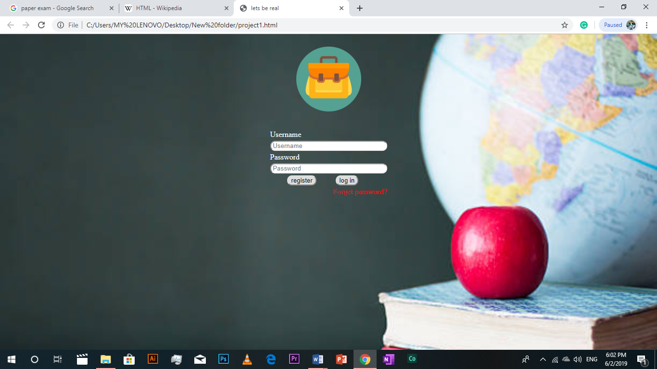

***2. Home page***



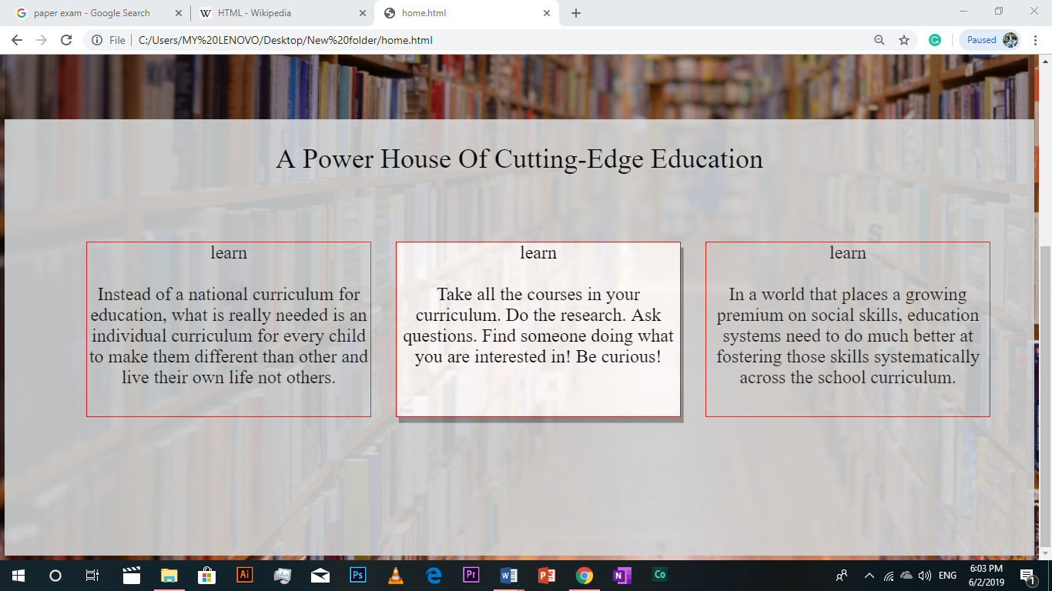

***3. Curriculum page***

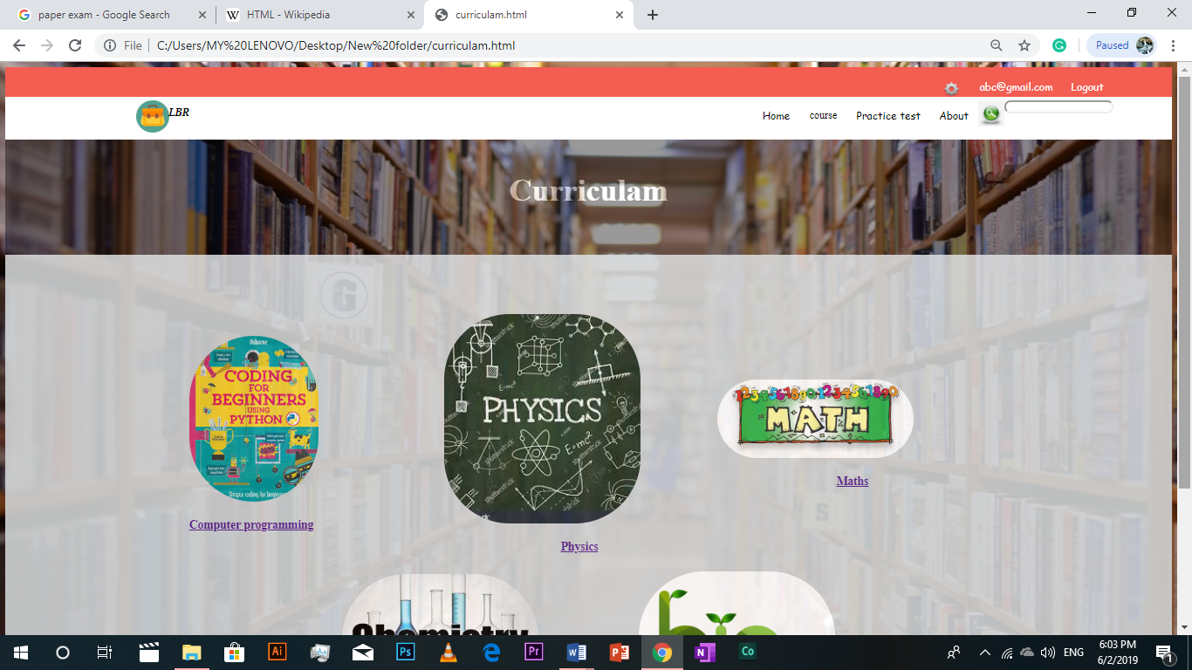

***4. Co-curriculum page:***



***5. Practice page:***

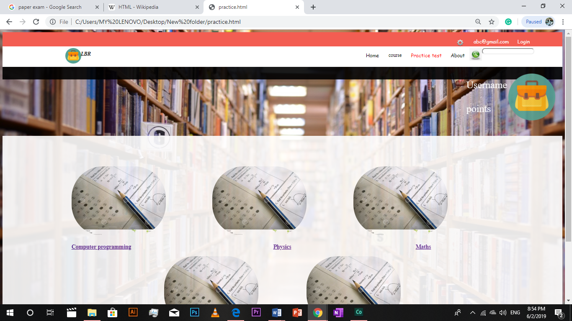

***6. About us page:***



***7. Setting page:***



***8. Register page:***



4. Result And Discussions:

This website will help students to learn from home. It will help them to learn different things from all around the world. Many researchers have agreed that discussion in online classes enhances student learning and facilitates social interaction (An, Shin, & Lim, 2009; Andresen, 2009; Hew & Cheung, 2013; Hrastinski, 2008). Online discussion also creates opportunities to enhance student learning through collaboration (Palmer, Holt, & Bray, 2008; Hew & Cheung, 2013). Specifically, the nature of discussion allows each student equal opportunity to participate in and create collective knowledge by sharing and elaborating ideas. Through collaborative knowledge-building processes, each student becomes reflective, thinks critically, and understands concepts better than if she or he were studying alone (Hew & Cheung, 2013).

5. Conclusion and future scope:

In future this website will not only helpful for students but also for teachers so that they can show their knowledge and intelligence here. Also it will allow students all around the globe to interact with each other in group chats and discussion. New courses will be provided with video lectures.